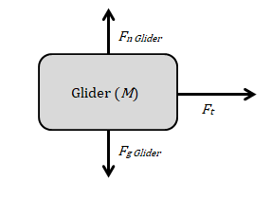

*Fg Mass*

*Ft*

Mass (*m*)

*Fn Glider*